Instructions

Write a program that defines the named constant PI, const double PI = 3.14159;, which stores the value of π. The program should use PI and the functions listed in Table 6-1 to accomplish the following:

Output the value of √π .

Prompt the user to input the value of a double variable r, which stores the radius of a sphere. The program then outputs the following:

The value of 4.0πr², which is the surface area of the sphere.

The value of (4.0/3.0)πr³, which is the volume of the sphere.

You should format your output like the following example:

Surface area of the sphere: 4 \* PI \* 5.00 ^ 2 = 314.16

Volume of the sphere: 4 / 3 \* PI \* 5.00 ^ 3 = 523.60

Your output must match the wording precisely to earn full credit.

Table 6-1

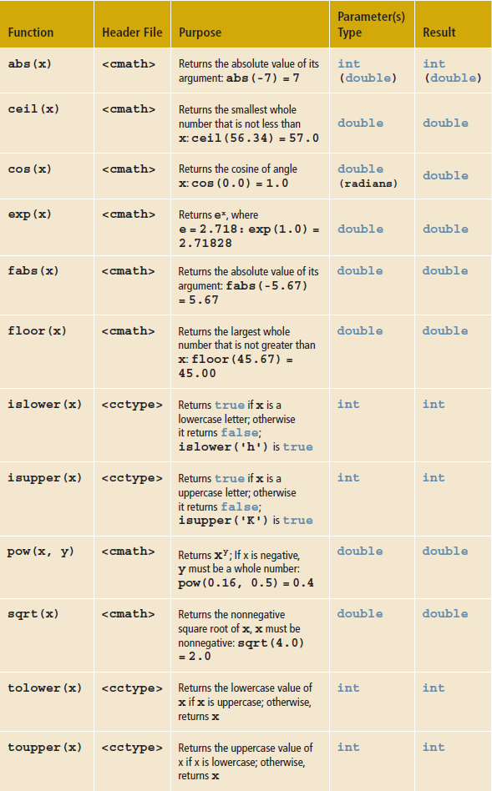

Grading

When you have completed your program, click the Submit button to record your score.

Tasks

10.00

out of

10.00

Uses pi and r with successful output

0

4 out of 4 checks passed. Great work!

Checks

Code PatternComplete

Checks for use of pi

Description

Searched your code for a specific pattern:

(const)\s\*(double\s\*PI\s\*=\s\*3.14159;)

You can learn more about regular expressions here.

Code PatternComplete

Checks for declaration of r

Description

Searched your code for a specific pattern:

\s\*(double\s\*r;)

You can learn more about regular expressions here.

Test CaseComplete

Checks output of r

Input

3

Output

sqrt(PI) = 1.77

Enter a value of r: 3

Surface area of the sphere: 4 \* PI \* 3.00 ^ 2 = 113.10

Volume of the sphere: 4 / 3 \* PI \* 3.00 ^ 3 = 113.10

Results

Surface area of the sphere:Volume of the sphere:113.10113.10

Expected Output

Surface area of the sphere:Volume of the sphere:113.10113.10

Test CaseComplete

Tests output of r

Input

4

Output

sqrt(PI) = 1.77

Enter a value of r: 4

Surface area of the sphere: 4 \* PI \* 4.00 ^ 2 = 201.06

Volume of the sphere: 4 / 3 \* PI \* 4.00 ^ 3 = 268.08

Results

Surface area of the sphere: 4 \* PI \* 4.00 ^ 2 = 201.06Volume of the sphere: 4 / 3 \* PI \* 4.00 ^ 3 = 268.08

Expected Output

Surface area of the sphere: 4 \* PI \* 4.00 ^ 2 = 201.06Volume of the sphere: 4 / 3 \* PI \* 4.00 ^ 3 = 268.08